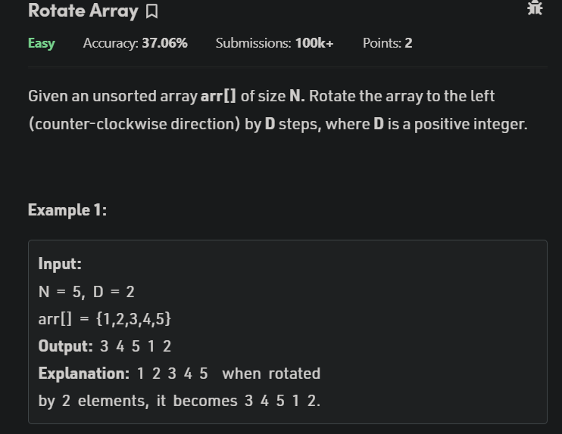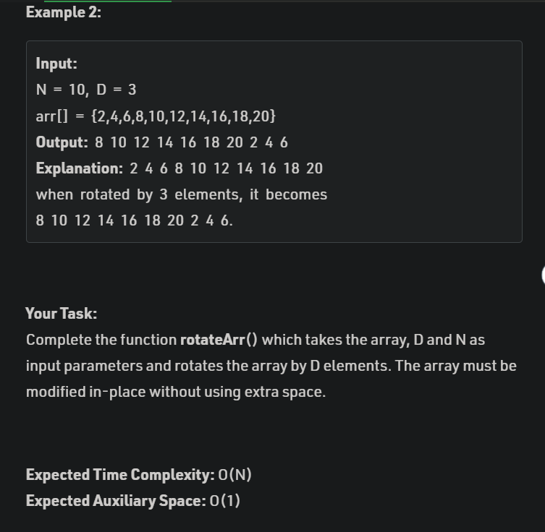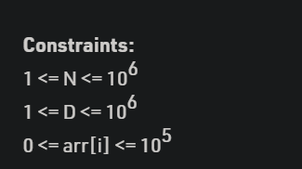

CODE

class Solution

{

//Function to rotate an array by d elements in counter-clockwise direction.

static void Reverse(int arr[], int start, int end)

{

int temp;

// int start=0, end=n-1;

while(start<end){

temp = arr[start];

arr[start] = arr[end];

arr[end] = temp;

start++;

end--;

}

}

static void rotateArr(int arr[], int d, int n){

d = d%n;

Reverse(arr,0,d-1);

Reverse(arr,d,n-1);

Reverse(arr,0,n-1);

}

}